**3. Olefin Metathesis in Polymer Chemistry**

Ring-opening metathesis polymerization (ROMP) is a way of making polymers from a variety of cyclic olefins. The structure of well-defined catalysts can be manipulated systematically in order to control the structure of ROMP polymers at an increasingly detailed level. Strained monomers are best suited for ROMP, since secondary reactions of relatively unstrained C=C bonds in the resulting polymer thereby can be minimized, the polymerizations can be living, and the polymerization is not potentially complicated by formation of ethylene. Norbornenes, 5,6-disubstituted norbornenes, and 2,3-disubstituted norbornadienes have been popular because they are relatively inexpensive and can be prepared in large variety. The object in recent years has been to understand ROMP process at the most basic level for polymers formed with simple norbornenes and norbornadienes. Four structures can be formed from a symmetric norbornene, namely *cis,syndiotactic*, *cis,isotactic*, *trans,syndiotactic*, and *trans,isotactic*, as shown in Figure 1 for norbornene itself. The goal is to understand how to form as many of these regular structures as possible in essentially 100% purity. In general, formation of ROMP polymers with a single structure is not possible with classical metathesis catalysts, with very few exceptions.



Figure 1. The four possible structures of poly(norbornene) and the two hydrogenated versions.

In 1993 it was discovered that *cis,isotactic* polymers can be prepared with biphenolate and binaphtholate catalysts through enantiomorphic site control (approach of the monomer to the same side of the M=C bond in each step). Several years ago we began to employ MAP complexes such as Mo(NAr)(CH-*t*-Bu)(OHIPT)(Pyrrolide) or, more recently, W(O)(CH-*t*-Bu)(OHMT)(Me2Pyr) as initiators for ROMP. A key detail is that the configuration of the metal in a MAP complex usually inverts with each insertion of monomer, which results in approach of the monomer first to one side of the M=C bond and then the other. This behavior gives rise to formation of *cis,syndiotactic* polymers with catalysts that are *Z*-selective, in contrast to *cis,isotactic* polymers formed when biphenolates or binaphtholate catalysts are employed. This "stereogenic metal control" has little precedent in polymer chemistry. Calculations suggest that the monomer approaches the metal *trans* to the pyrrolide in each step, as shown in Figure 2. Monomers that have been polymerized to give *cis,isotactic* or *cis,syndiotactic* polymers are shown in Figure 3. When hydrogenated polymers are the goal (Figure 1), as in hydrogenated poly(dicyclopentadiene), both tacticities for the hydrogenated polymer are now available. Hydrogenated polymers with different tacticities can have dramatically different properties. The ability to explore these possibilities fully has only recently been possible with stereospecific polymerization by well-defined initiators.



Figure 2. The mechanism for forming *cis,syndiotactic* polymers.



Figure 3. Monomers that have been polymerized to give *cis,isotactic* or *cis,syndiotactic* polymers.

Some monomers have never been polymerized, and most have not been polymerized to give stereoregular polymers. Some recent examples of both types are shown in Figure 4. But W(O)(CH-*t*-Bu)(Me2Pyr)(OHMT), especially when activated with B(C6F5)3, is able to polymerize all monomers shown in Figure 4 to give stereoregular polymers, with the exception of **1d**. An especially interesting case is **1c**, which is *polymerized stereoregularly only in the presence of B(C6F5)3*.



Figure 4. Monomers that have been polymerized stereoregularly with a tungsten oxo catalyst.

When the monomer contains a chiral element, and a polymer with a highly regular structure is obtained, then it is possible to assign the tacticity through proton NMR methods. For example, the polymerization of enantiomerically pure 5,6-(R)2Norbornenes can give the regular structures shown in Figure 5. Only the *cis* structures can be obtained in pure form, although mixtures of only two of the four have been observed in some cases, e.g., *cis,syndio* and *cis,iso* or *cis,syndio* and *trans,iso.* These studies are helping reveal some of the exceedingly subtle features of polymerization by well-defined initiators.

Studies concerned with the polymerization of *racemic* chiral monomers, such as *rac*-5,6-dicarbomethoxynorbornene has led to the discovery of a special form of an AB copolymer, a perfect incorporation of enantiomers A and B alternately employing molybdenum-based MAP catalysts. The reason is that the chirality at the metal center in a MAP catalyst inverts with each insertion, and each of the enantiomers at the metal reacts selectively with one enantiomer of the substrate. An example is shown in Figure 6, which was prepared employing Mo(N-2,6-Me2C6H3)(CHCMe2Ph)(pyrrolide)(OHMT) (**2**) as the initiator. This (unpublished) example appears to be >99% a poly(A-*alt-*B) structure according to the single sharp resonances observed for HC, HB, and HA protons in the proton NMR spectrum. So far, attempts to carry out the synthesis of A-*alt-*B polymers with tungsten catalysts as initiators have led to polymers with no regular structure. A logical extension of this research is the synthesis of A-*alt-*B polymers where A and B are not enantiomers, but different cyclic monomers incorporated alternately in a ROMP reaction.



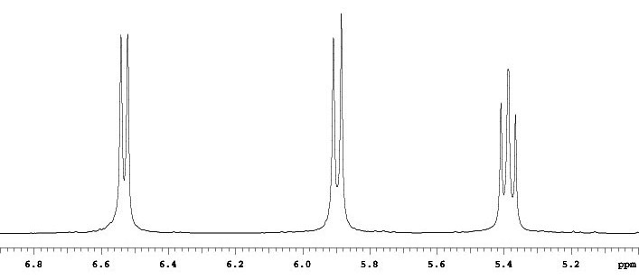

**HC HA HB**

Figure 6. A partial proton NMR spectrum of the   
*cis,syndiotactic*-poly(A-*alt-*B) polymer made with **2**.



Figure 5. The four regular structures of poly(5,6-(R)2Norbornene)s.

We believe the results obtained in stereoregular ROMP suggest the complex principles of ROMP are being brought under control to a significant degree, although clearly much remains to be done with the now hundreds of catalysts available to serve as initiators.

The following relatively recent papers are relevant to this area of research (see the complete publication list for others): 494, 510, 515, 519, 534, 537, 544, 549, 555, 556, and 557.